Thankful Pie

Not only is Thanksgiving a time to enjoy delicious food, but it also offers us a moment to pause and reflect on those things that mean the most to us. To celebrate both of these Thanksgiving traditions, we invite you to make a Thankful pie. This easy and relaxing activity will let you put your artist stamp on a Thanksgiving staple, pumpkin pie!

Materials:
- Thanksgiving Pie Template
- Scissors
- Crayons, Colored Pencils, or Markers
- Glue or Tape
- Extra Printer or Construction Paper

The Activity:
The written instructions are accompanied by images below.

Step 1. Gather your materials. Make sure to choose your favorite drawing utensil!
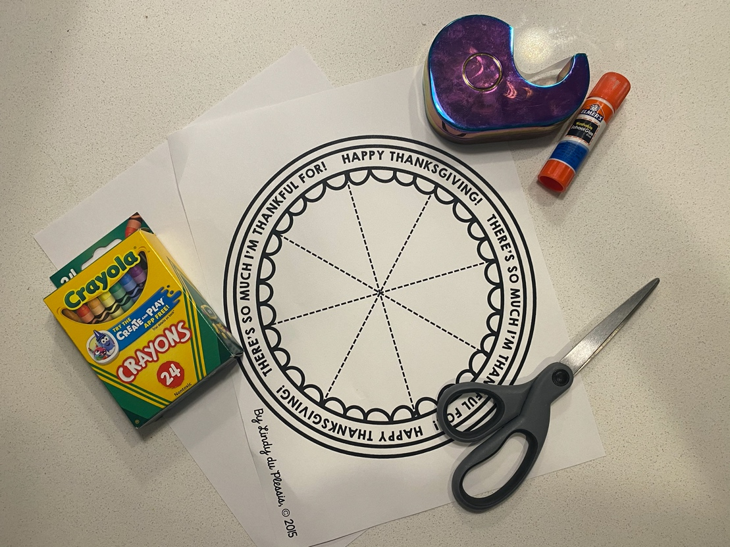

Step 2. Color your pie. Get creative with your pie and feel free to add toppings

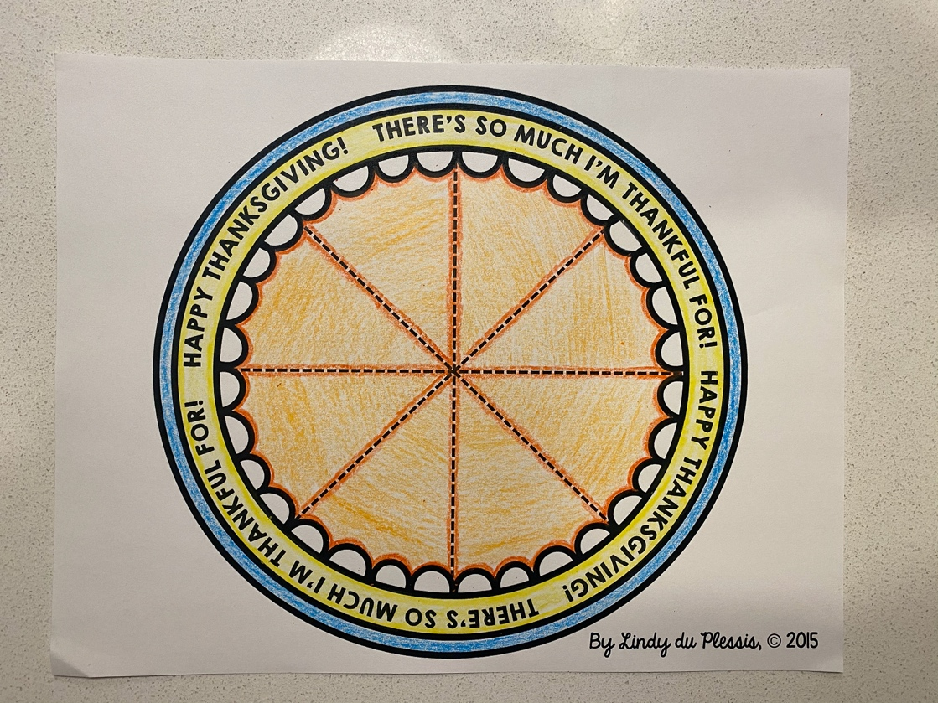

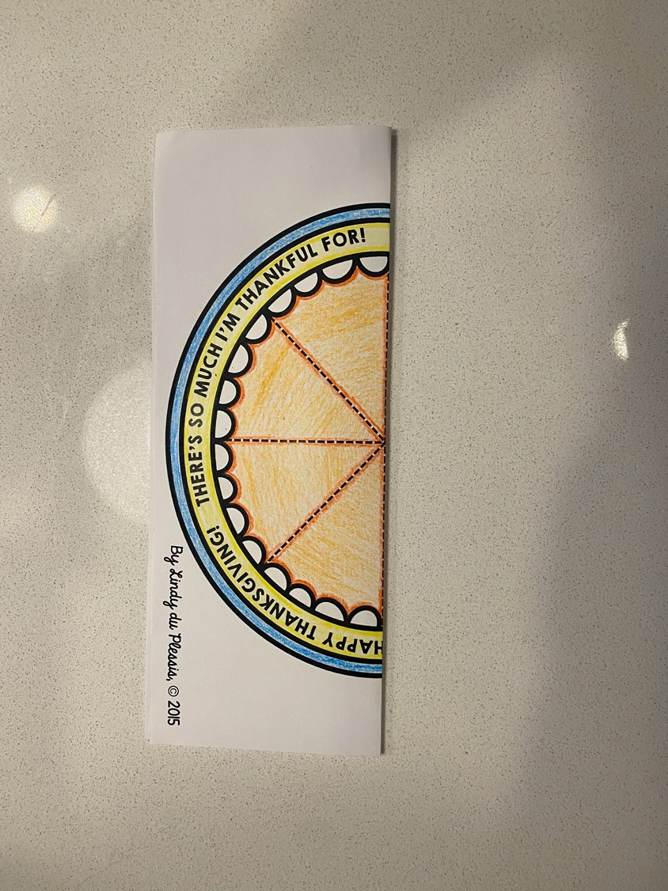
Step 3. Fold your pie in half, hotdog or hamburger style will work. Use your scissors to cut along the dotted lines to create pie slices.

Step 4. Once your pie pieces have been cut, glue or tape your pie to a piece of blank white paper.
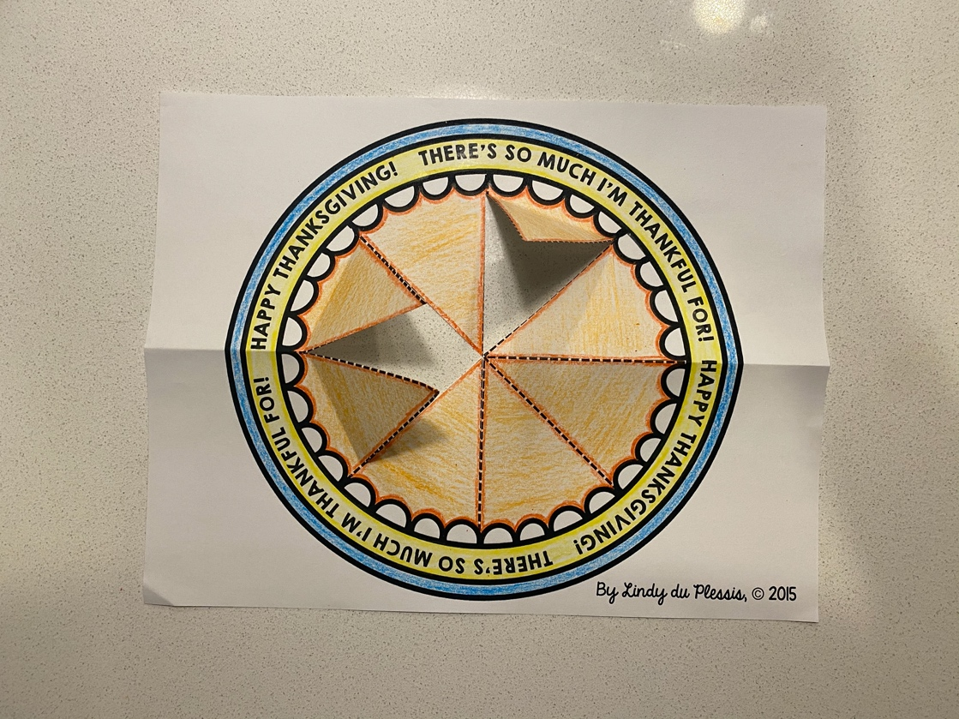

Step 5. Fold back your pie slice and think of something you’re thankful for. This can be anything from your friends to the food you ate today. Regardless, use this as a chance to think about those things that make you happy. Write down a thankful thought underneath each slice. When you’re done, remember to share your pie with those you love!

