Thanksgiving I Spy
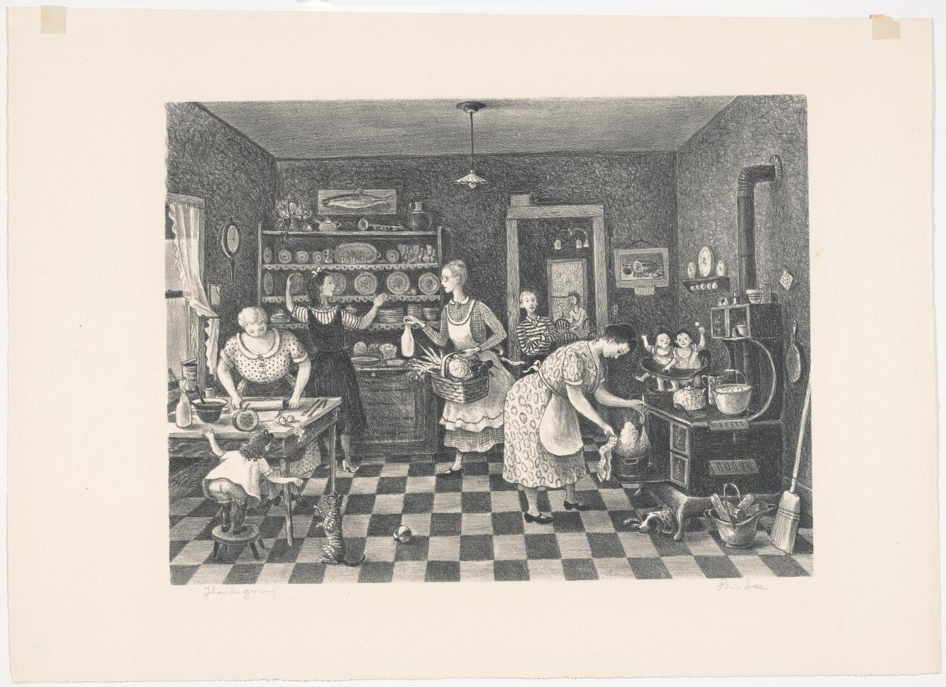
Doris Lee, American, born 1905, Thanksgiving, published 1942, lithograph, 8 7/8 x 11 7/8 in. (22.5 x 30.2 cm). Ackland Art Museum, University of North Carolina at Chapel Hill. Gift of W.P. Jacocks, 58.2.246.

The Activity:
At the Ackland we enjoy the practice of “Close Looking.” We encourage our visitors, including online visitors, to look close and think far. We often start conversations about art and its meaning by asking “what do you see?” In this activity, we want to give you the chance to practice your close looking skills with Doris Lee’s 1942 lithograph entitled Thanksgiving. You may be surprised by how many details you discover!

Step 1. It can sometimes be difficult to view images digitally. First download Doris Lee’s Thanksgiving so that you can zoom into the image.
https://ackland.emuseum.com/internal/media/dispatcher/15618;jsessionid=EBB7C85DCEF0B6A9B0CDE21686737B13?download=

Step 2. Now that you have the image open, it’s all about first impressions. This is your first chance to look at the image up close and you immediately notice that there’s a lot going on! Before we dive into the details, start by looking at the image from a bit further away.
Think about these questions while you think about the image in its entirety:
- What is this image depicting?
- What are the figures in the image doing and who do you think they might be?
- What objects in the image make you think of Thanksgiving?

Step 3. After spending some time with a work of art, you start to notice some elements that you may not have seen when you first encountered it. Now that you’ve looked at Thanksgiving from afar, it’s time to zoom in and start to analyze the details. To finish this activity, we want you to play I Spy! We have a list of items for you to find, but we also challenge you to find things that are not listed.

I Spy...
- A rolling pin
- A tea pot (Hint: there are two!)
- A dog
- A cat
- A pepper shaker
- A loaf of bread
- A pair of twins
- A pair of glasses
- A trumpet
- A clock
- A broom
- A spoon
- A fish
- A light switch
- A turnip
- A bucket of logs
- A turkey
- A calendar
- A bow
- A carrot

